**Hbase Assignment- Task 3**

1. **Create a table album in hive with the following data.**

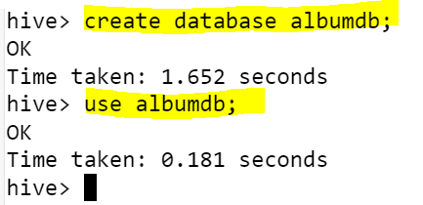

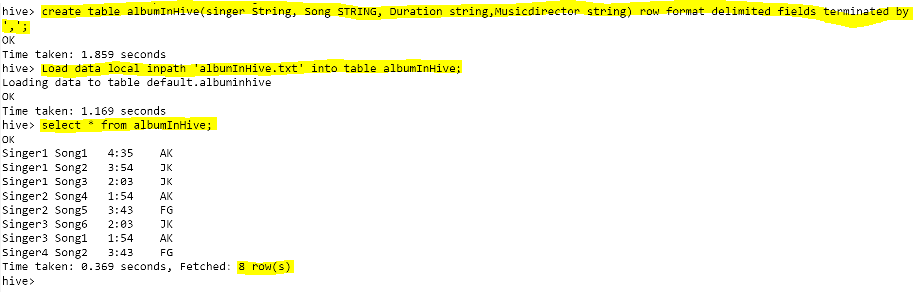

1. **Create a table in Hbase (using hive-hbase integration) with proper row key design efficiently to load the data from hive to hbase.**

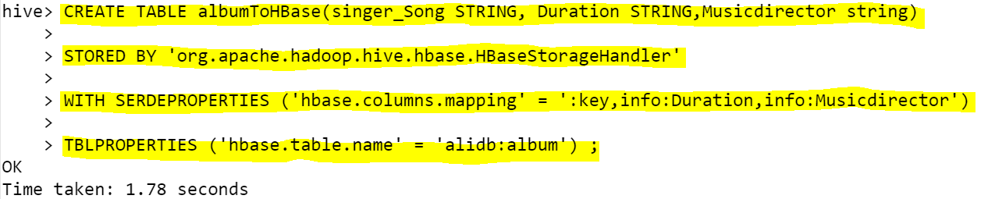

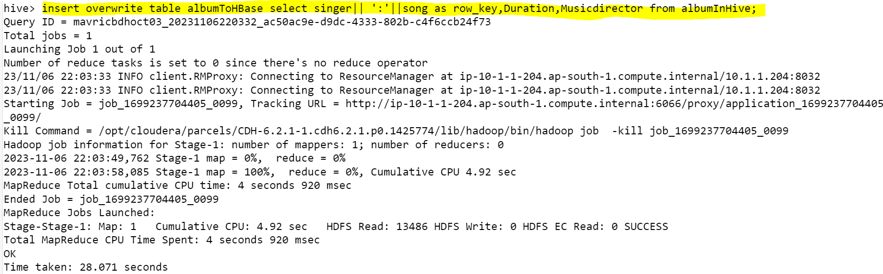

1. **There should not be any data loss when moving data from hive to hbase.**

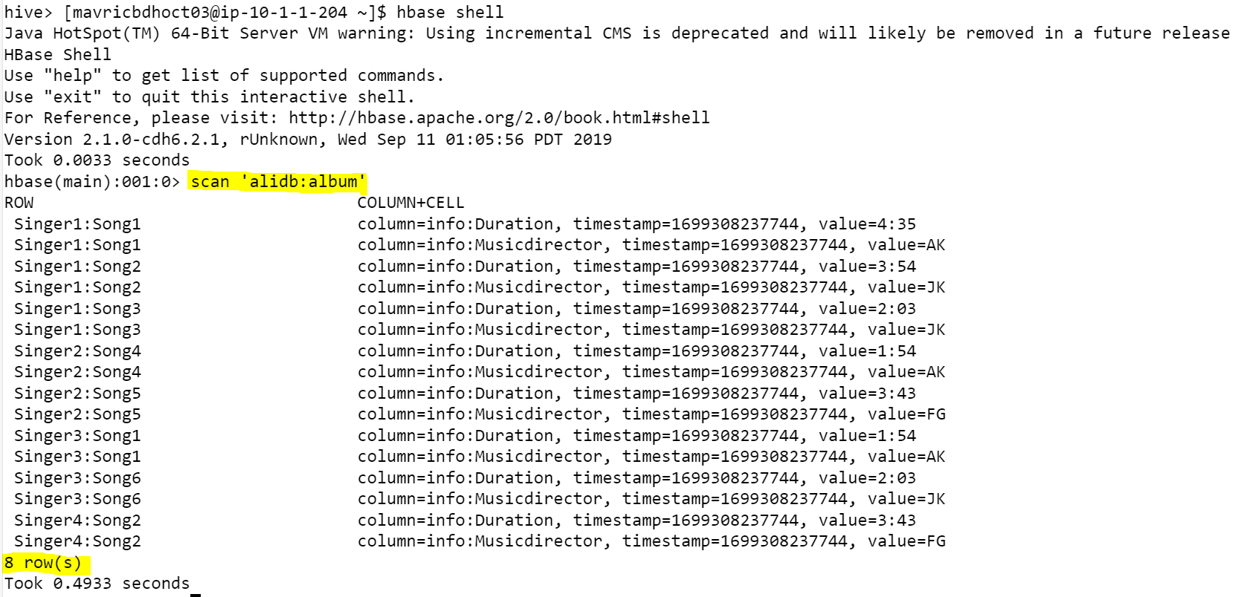

1. **Run queries like**
2. **get all songs sung by a singer**

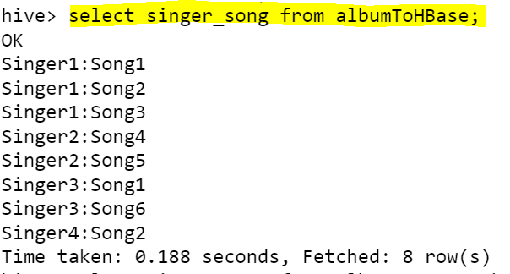

1. **Which singer sung for music director AK and what were the songs.**

